SaintMUN 2019

African Union
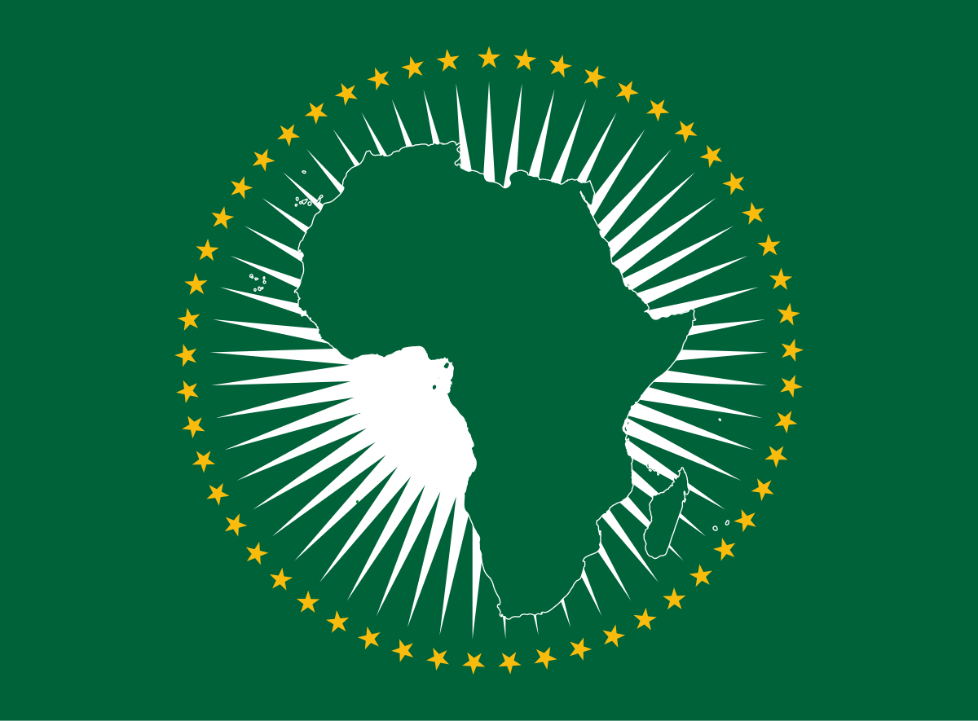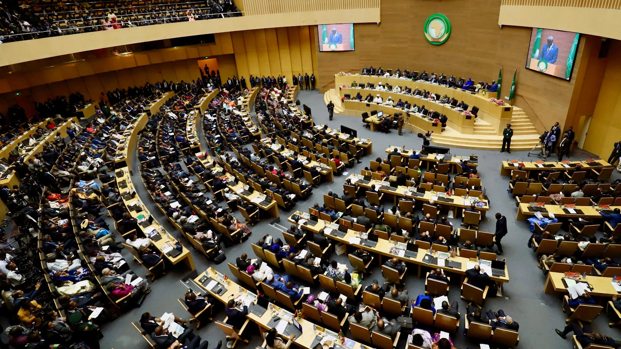
Study Guide
Dear Delegate,

Welcome to SaintMUN's simulation of the African Union (AU). We hope that you are as excited for this as we are. We have two incredible topics, both of which we will absolutely certainly really-we-will-honestly get to discuss in the depth that they deserve. They are, in no particular order, the ongoing situation in the Western Sahara, and digitisation of the African economy, both of which are issues of profound importance to the continent as a whole.
The AU is a unique body in international affairs. A supranational entity with the capacity to authorise military action, the AU is almost unique in the scope of its power, and, indeed, in its member's willingness to exercise that power. The AU also strives to become a more interconnected economic union, similar in principle to the European Union's Single Market. In these two ways the AU is unmatched in its ambitious grant of supranational authority.
We hope to simulate this optimistic and sometimes contentious atmosphere in our debates. Africa is a continent divided by entrenched national interest and a history of arbitrary colonial division, and it is our objective to bring those fault lines into relief. But we can't do this without you. So please read the following pages thoroughly so that you can gain a sense of the history of these issues.
Finally, we are very much looking forward to seeing you in St. Andrew's this October. Happy researching!
Best,
Ellasandra
Justinus
Gethin

Topic A: Digitalisation and African Development

Introduction
In recent years growth throughout the African continent has started to slow; rates are beginning to look meager in light of the rapid population expansion throughout the region. North America, Europe and large parts of Asia are facing stagnating population growth, but Africa will continue to grow past 2100, when the population is projected to exceed 4.1 billion people. As a result of this, Sub-Saharan Africa is one of the only regions globally experiencing an increasing number of individuals living in absolute poverty (Todaro & Smith, 2015).

The African economy is dominated by a dependency on subsistence agriculture and 72% of economic activity remains concentrated in the informal sector (Jackson, 2016). Whilst large parts of the developed world and emerging markets have all managed to harness the power of technological change to the benefit of their own economies, in Africa, technology has yet to “bridge the efficiency gap between tradition and progress.” (ThinkProgress, 2019). Technology has the potential to solve fundamental asymmetry issues and reduce transaction costs between economic stakeholders, facilitate greater access to education and attract the necessary foreign investment to kick start growth. The knock-on externalities of digital advancement are countless and difficult to quantify. However, the empirical evidence overwhelmingly paints a picture of a strong association between various indicators of digitalisation and living standards (see the World Bank’s Africa pulse report). African countries have mixed levels and qualities of digital infrastructure networks such as cell-phone coverage, and access to internet and electricity. However, a common challenge amongst the majority of countries is how to seize opportunities of a new digital environment and channel these into growth.

Digitalisation can be defined as “the use of digital technologies to provide new revenue and value-producing opportunities” (Forbes, 2018). Our African Union committee will examine this far-reaching socioeconomic phenomenon in the greater context of Africa’s ongoing developmental process. How can the economy and society benefit from technological process in an equitable way? How can we harness the true power of this transformation to generate equitable growth? These existential questions will be crucial for African policymakers throughout the next century. At the heart of issue, lies a necessity to collaborate. Integrating digitalisation efforts across borders and exchanging information will provide pivotal in truly harnessing the benefits from the continent’s digital transformation. This is where the African Union can step in to facilitate negotiations and foster long-term cooperation amongst African nations.

This topic will be split into several subsections. We will examine the existing digital infrastructure of the continent, the opportunities of digital entrepreneurship, and take a more detailed look at the agricultural and financial sectors.

Digital Infrastructure

Digital infrastructure is defined as a country’s ability to exchange data through a consolidated communication system. This may include a multitude of channels such as digital platforms, networks and mobile phone and internet systems. We will focus here on internet broadband in greater detail. Not only is the “quantity” of the digital infrastructure of interest (i.e. usage, coverage, penetration) but also the quality in terms of speeds and prices.

Fixed broadband penetration in Africa has increased sevenfold between 2007 and 2017; but only from a meager 0.7 to 0.34 subscriptions per 1,000 inhabitants (World Bank, 2019). Meanwhile, developing countries have exceeded the 100 mark whilst advanced countries have attained levels higher than 350. Within Africa, the sub-Saharan region lags far behind the more developed North (see Figure below).

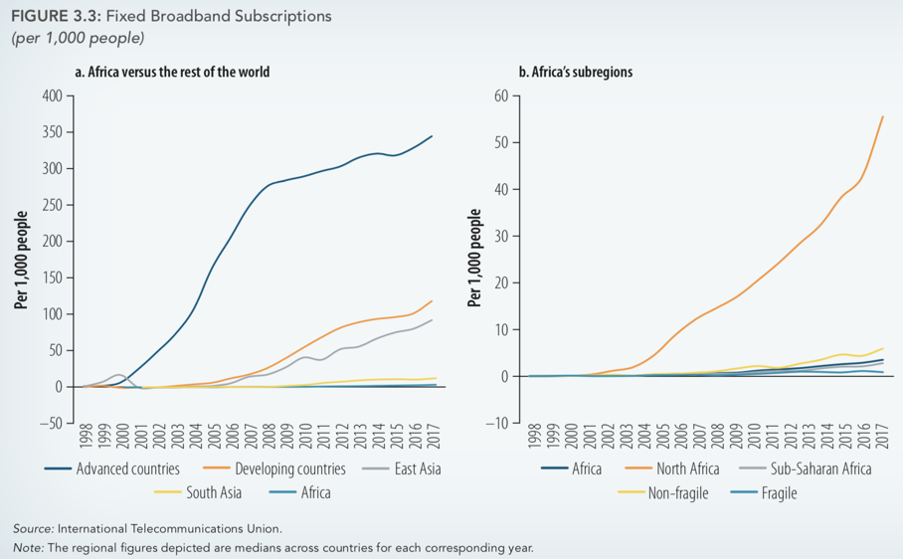

The disparity in connection is largely due to higher prices of broadband in conflict riddled regions. Where supply lines are disrupted and a healthy competition of network providers is unable to flourish, internet prices are significantly higher. Meanwhile however, mobile broadband (in form of 3G or 4G) is becoming increasingly popular on the continent. Whilst the advanced economies are still ahead, penetration of cellular data subscriptions were only twice as high as in Africa in 2017 (ibid). The latter form of internet access seems much more attainable for individuals in remote areas lacking access to underground broadband lines and desktop computers to tap into conventional fixed broadband. Fixed broadband is much more costly to construct due to geographical barriers; it does however typically provide a more stable and secure connection (ibid). Moreover, in terms of mobile broadband speed, Africa is even further behind the developed West. When it comes to 4G subscriptions, advanced economies had rates of over 800 subscriptions per 1,000 inhabitants in 2017, whilst Africa lagged behind at under 50 (ibid).

Quantity and quality of digital infrastructure depict an image of regional disparities. The North is slightly ahead whilst some more fragile states in the sub-Saharan region are lagging behind. The result of this is a digital divide, between the global north and south, but also within Africa. In poorer, less stable regions literacy rates are lower, broadband is less affordable and more basic human survival needs are addressed. Where this is the case, digital access and skills are insufficient for a society to harness the advantages of technology, let alone channel these into economic growth. There is furthermore a very apparent gender divide in access to technology in many African countries. Not only do women have lower literacy rates, but “patriarchal structures and cultural practices hinder access further.” (Schelenz & Schopp, 2018). Access may be restricted to the man of the household, who may deem the internet inappropriate for his wife or daughter, or prevent them from acquiring greater digital skills (ibid.).

Digital Entrepreneurship

The digital economy allows for a simple entry into entrepreneurship. Individuals can start a business from their home with very little capital equipment or labour intensive production methods. An app, website or programme – depending on its complexity – can be designed from a laptop, tablet or even smartphone. Innovation drives productivity but also allows individuals to exit the informal sector and traditional agricultural subsistence employment. Several hotspots throughout the continent, such as Rwanda, Kenya and Malawi are innovation “achievers” known particularly for their production of intangible assets, online service and innovation and knowledge creation (Acs, et al., 2018). Outside of these innovative clusters, insufficient efforts have been diverted to encouraging start-ups, particularly those capitalizing on digitalization.

In order to further facilitate the rise of digital entrepreneurship, African governments could start with the following key approaches:
• ICT Education: technological literacy should be supported from a very young age. School programmes can prepare children for the digital era by teaching them basics on how to use mobile phones and computers or even more advanced skills such as coding. Even more important will be to expand ICT degree programmes at universities as well as provide retraining opportunities for individuals currently working in the traditional sector.
• Investment: governmental investment in digital infrastructure and education will help kick-start the market’s own efforts, especially where market failures persist and upfront capital costs are prohibitively high for private enterprises. Moreover, foreign direct investment (FDI) from abroad can help bridge the gap between the necessary investment stock needed and what African governments themselves can provide. Foreign investors will be more prone to investing where the existing digital infrastructure is already of a higher quality.
• Conventional entrepreneurship policies: Favorable loans, grants, tax relief and other forms of financial support should be given to innovative digital start-ups. Moreover, the process of creating a business could be streamlined and deregulated. Institutional factors such as strengthening property rights and the rule of law and a crackdown on corruption have a major effect of boosting entrepreneurship and attracting greater inflows of FDI.

Agriculture

The digital transformation in Africa is unique in the sense that the most crucial innovation is occurring in the agriculture sector. As most of the population is surviving off of subsistence farming utilizing traditional methods, the potential for digital technology to modernize and improve productivity is immense. Higher productivity and less labour intensive production methods would allow more people to enter more productive sectors (namely services) and increase the competitiveness of agricultural exports.

The World Bank highlights three mechanisms through which ICT can aid the agricultural sector:
• Promotion of market transparency: access to internet and mobile phones helps reduce information asymmetries and allow individuals in isolated areas to become connected to regional / national markets. Empirically, the promotion of market transparency can be seen in considerable reductions in price dispersion of key agricultural goods throughout several African countries. For instance, the introduction of mobile phones reduced grain price dispersion in Niger by “at least 6.5 percent and intra-annual price variation by 10 percent” (World Bank, 2019).
• Boosting farming productivity: individuals now have much greater access to knowledge about farming methods, allowing them to troubleshoot problems relating to machine maintenance for example. Moreover, they have access to information about new seeds, tools or revolutionary agricultural practices.
• Reduction of logistics costs: digital platforms have made it easier for sellers to become connected with buyers on the market, or for farmers to order and schedule a delivery for vital inputs such as seeds or machinery.

Individual startups have successfully innovated the agricultural sector through one or more of these channels. For example, Zenvus, a startup from Nigeria, has developed a series of electronic sensors that collect data on soil moisture and nutrient density. The information the sensors gather is sent to a cloud-server via an app for analysis. From there, the company can advise individual farmers on how to adjust their irrigation and planting practices so as to maximize their yield (UNEP, 2018). Another startup is HelloTractor which allows farmers to lend capital machinery, schedule delivery and provide payment in advance. The company has been dubbed the “Uber for Tractors” (Foote, 2018) and has enabled small-scale farmers, unable to finance their own tractors, to meet their capital needs. These start-ups are booming across several African countries, providing a host of innovative solutions aimed at modernizing the agricultural sector.

Financial Sector

Most African developing countries experience vicious poverty traps with dysfunctional capital markets that cannot fulfill the financial needs of large parts of the population. People in isolated areas have historically been unable to acquire loans or access the banking system due to geographical barriers. Furthermore, most individuals living in poverty, lack the collateral to acquire loans in the first place.

Where geographical isolation and an insufficient conventional banking system persist, mobile banking can help connect individuals to the banking system. As of 2017, about 1 in 5 people in the sub-Saharan region have a mobile money account, more than any other region in the world (World Bank, 2019). Penetration of this new form of banking is rapidly expanding and is “extending financial services to people with limited access to traditional financial institutions, notably, women and rural populations.” (ibid). Individuals can pay bills using text messages, transfer money or apply for small-scale loans from financial institutions. In 2017, around one in four Africans made digital payments (ibid). This is providing a significantly less costly and safer way of conducting transactions than carrying around larger sums of cash, particularly in unstable, conflict-affected regions.

Again, a mixed picture persists with significant regional disparities. Some countries such as Namibia or Kenya have impressive rates of mobile money ownership, with over 50% of the population owning an account (World Bank, 2019). Others, such as Mali, Niger or Chad are falling far behind, with only around 10% of the population having access to mobile or formal finance. This is where those countries that have had experience in rolling out a mobile banking system can come in to share their expertise with those lagging behind. Moreover, developing a streamlined AU-wide real-time payment system similar to the Eurozone’s SEPA or the UK’s BACS, could help make transfers become more seamless, and integrate money-markets across the continent.

Conclusion

In summation, the digital transformation is in full effect in the world’s second largest continent. It remains up to African governments to make the most of it, and mitigate the potential side effects of its rapid expansion. African leaders have called for a common agenda on digitalization earlier this year and pledge to ease trade across borders whilst focusing on the issues of digital skills, literacy and cybersecurity (African Union, 2019). It is now time for you to develop a more comprehensive agenda and look at implementation strategies.

Looking into the future, socio-economic development in Africa will be vastly influenced by two major exogenous factors. One is the ever-growing threat of climate change and the growing pressure from the industrialised high-income countries on developing nations to reduce their footprint. The second factor is the resurging influence of foreign powers, namely China and the EU, who wish to secure a stake in the continent’s promising economic prospects in the coming decades. With these in mind, it must be debated how best to provide prosperity and security for African citizens, in a transforming global arena.

Key Questions
1. How can the AU collaborate to expand continent-wide digital coverage?
2. Are there inequalities in Africa’s digital transformation and how can these be rectified?
3. How can we encourage people to exit agricultural self-employment and move into higher-value added sectors?
4. How do we close the gap between necessary and available funding for investment in the digital infrastructure?
5. What role can FDI and trade have in aiding Africa’s digital transformation?
6. How can we encourage digital entrepreneurship and innovation?
7. How can we implement digital innovations to modernise agricultural practices?
8. How can we implement digital innovations to expand access to finance?
9. Should we, and how can we digitally integrate financial markets across African countries?
10. What are the dangers of the digital transformation for African development?

Further Reading
- Africa Pulse (World Bank): quarterly series by the World Bank to give an overview of Africa’s economic situation. This specific issue has an extremely well detailed section covering the precise topic of our committee. https://openknowledge.worldbank.org/handle/10986/31499
- What Technology can do for Africa (Economist): a concise yet comprehensive introductory article https://www.economist.com/special-report/2017/11/10/what-technology-can-do-for-africa
- Digitalization in Africa: Interdisciplinary Perspectives on Technology Development, and Justice (International Journal of Digital Society): A more nuanced evaluation of the equity implications the digital transformation has had in Africa https://infonomics-society.org/wp-content/uploads/ijds/published-papers/volume-9-2018/Digitalization-in-Africa.pdf

Bibliography
Acs, Z., Szerb, L. & Llyod, A., 2018. Global Entrepreneurship Index, s.l.: GEDI .

African Union, 2019. African Leaders call for a common Digitalization Agenda. Directorate of Information and Communication, 15 May.

Bank, W., 2019. Africa Pulse April 2019, Washington DC: World Bank Group / OFFICE OF THE CHIEF ECONOMIST FOR THE AFRICA REGION.

Bloomberg, J., 2018. Digitization, Digitalization, And Digital Transformation: Confuse Them At Your Peril. Forbes Magazine, 29 April.

Foote, W., 2018. Meet The Social Entrepreneur Behind Africa's "Uber For The Farm". Forbes Magazine, 14 August.

Jackson, T., 2016. Don’t underestimate the power of Africa’s informal sector in a global economy. Quartz , 21 January.

Schelenz, L. & Schopp, K., 2018. Digitalization in Africa: Interdisciplinary Perspectives on Technology, Development, and Justice. International Journal of Digital Society, 9(4), pp. 1412-1420.

ThinkProgress, 2019. Power to the people: The impact of digitisation in Africa. [Online]
[Accessed 15 August 2019].

Todaro, M. & Smith, S., 2015. Economic Development. 12th Edition ed. s.l.:Pearson.

UNEP, 2018. In Africa, tech-savvy entrepreneurs sow seeds of a farming revolution. 12 December.

Topic B: The Western Sahara Crisis

Introduction

Ever since the withdrawal of Spanish colonial holdings over Western Sahara in 1976, the region has been subject to a long series of territorial conflicts and undetermined governing authority, particularly between Morocco and the Polisario Front. While the African Union (AU) has historically recognized the Sahrawi Arab Democratic Republic (SADR) as being independent from Morocco despite differing positions of its member states and the world, the readmission of the economically dominant Morocco to the AU in 2017 has resulted in an extreme pressure placed upon the AU to amend its position on the conflict. In 2018, The AU chose to relinquish its authority on the issue to the United Nations (UN) in order to avoid a conflict of interest. However, in early 2019, two groups of member states organized coinciding events in order to gain support for their positions, indicating a growing discontent and a desire for a resolution- and bringing into question the responsibility of the AU to solve this expressly African issue.

The sections to follow will analyze the players, history, and key issues impacting the crisis so as to provide a general overview of the issue and frame the discussion to come at SaintMUN 2019. However, further research on possible discussion topics will be expected.

Parties Concerned

• The Kingdom of Morocco (Morocco): A prominent North African state, at the intersection of Europe, Africa, and the Middle East. Morocco is a parliamentary constitutional monarchy under King Mohammed VI with an estimated population of 34,314,130 (2018).

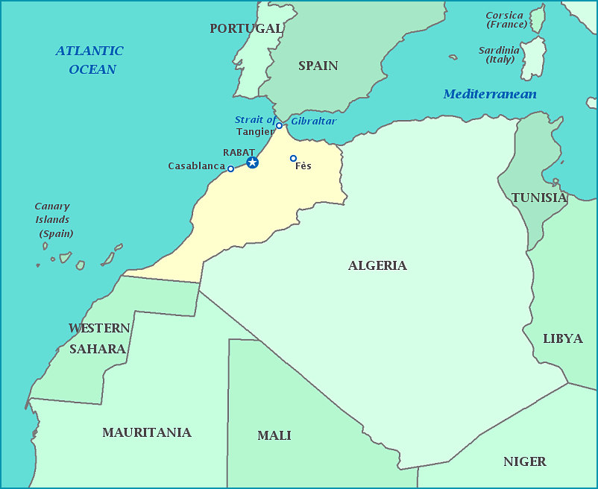
Figure 1- Map of Morocco
• Frente Popular de Liberación de Saguía el Hamra y Río de Oro (Polisario Front/ Frente Polisario): The leading political organization of the self-proclaimed Sahrawi Arab Democratic Republic (SADR) of Western Sahara. Backed by Algeria and recognized as a state by the AU, but classified as an occupied territory by the United Nations (UN). While the current legal and governmental status is unresolved, the current president of the SADR is Brahim Ghali. The population is estimated at 619,551 (2018) and is primarily comprised of the ethnic Sahrawi peoples, with a small constituency of Moroccan immigrants. While largely uninhabitable, one of the most attractive elements of this region is evidence of untapped oil reserves, although the quantity is unknown.
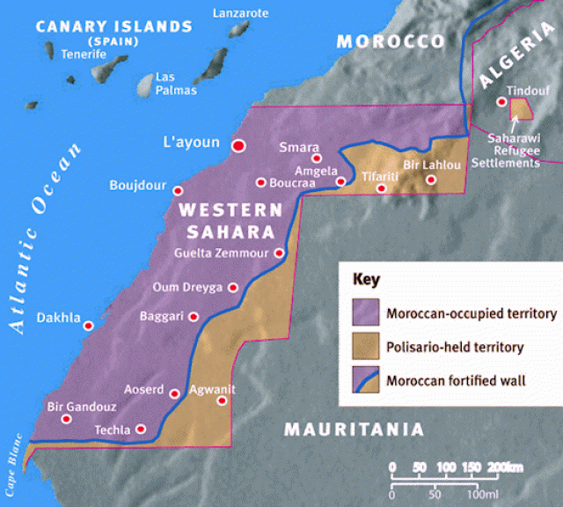
Figure 2- Map of Western Sahara

• United Nations Mission for the Referendum in Western Sahara (MINURSO): Established in 1991 by the United Nations Security Council (UNSC), MINURSO is currently responsible for the monitoring and maintenance of the ceasefire in Western Sahara, including providing logistical support to greater UN peace-building measures and monitoring for mines and other threats to the security of the region. While originally tasked with the organization and execution of a free and fair referendum in the region, this was later rescinded as unresolvable conflicts arose over the determination of qualified voters.
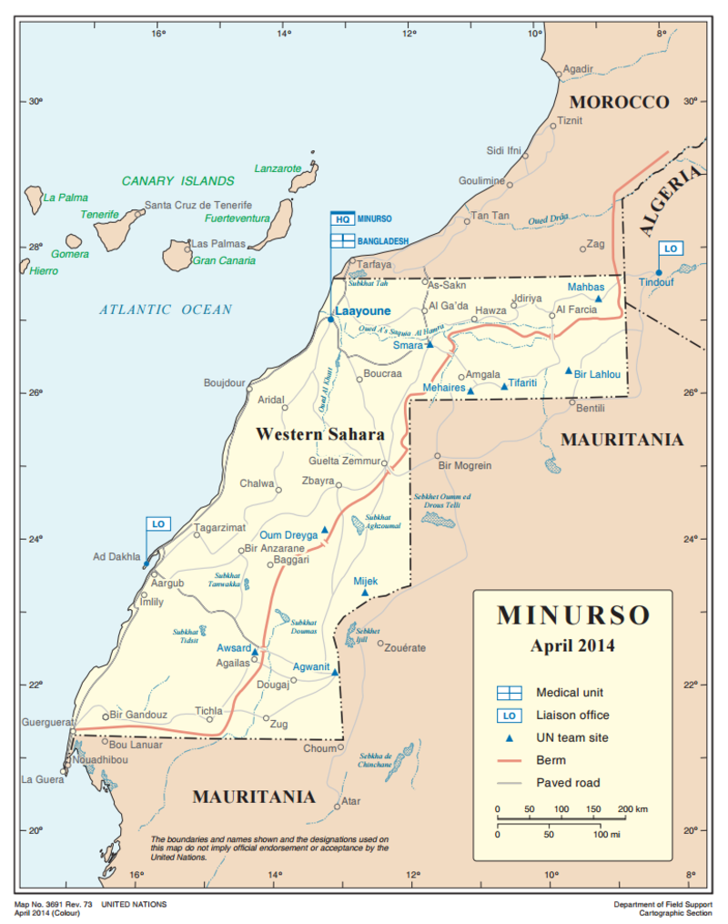
Figure 3- Map of MINURSO Activity in Western Sahara
• The African Union (AU); formerly the Organization for African Unity (OAU): Comprised of 55 member states, including the SADR (officially recognized and joined in 1982) and Morocco (joined in 2017), the AU seeks to establish “An integrated, prosperous and peaceful Africa, driven by its own citizens and representing a dynamic force in (the) global arena.” This is thought to be an extension of the OAU objectives, “to rid the continent of the remaining vestiges of colonization and apartheid; to promote unity and solidarity among African States; to coordinate and intensify cooperation for development; to safeguard the sovereignty and territorial integrity of Member States and to promote international cooperation within the framework of the United Nations.” (AU Website)

• The Peace and Security Council (PSC): A subcommittee of the AU. Formerly handled peace efforts on this issue, but in 2018 ceded authority to the UN in collaboration with the AU Troika and the chairperson of the AU Commission, currently Moussa Faki of Chad.

• The AU Troika: A leadership body of three heads of the AU comprising of the current chair of the AU, Egyptian President Abdel Fattah el-Sisi, the previous chair, Rwandan President Paul Kagame, and the incoming chair, South African President Cyril Ramaphosa. This group was commissioned by the AU Assembly Decision 693 (XXXI) in July 2018, and was created to represent the AU to the UN for the duration of the diffusion of the Western Sahara Crisis.

Crisis Timeline
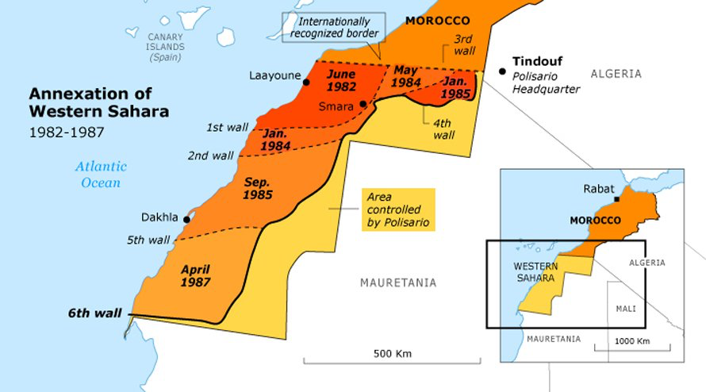
Figure 4- Annexation of Western Sahara

- 1975- Madrid Accords: Spain withdrew territorial claims over Western Sahara, ceding authority to Morocco (2/3 of the territory) and Mauritania (1/3 of the territory).
- 1976- Armed conflict erupts between the self-proclaimed Sahrawi Arab Democratic Republic (SADR) and Morocco
- 1979- Mauritania renounces its claims to Western Sahara, Morocco claims the remaining third of the territory
- Morocco tried to reintegrate the territory, causing fighting between the Polisario Front (supported by Algeria) and Morocco
- 1984- The OAU officially recognizes the Sahrawi Arab Democratic Republic (SADR), followed by the withdrawal of Morocco from the OAU in protest
- 1988- The UN, in collaboration with OAU, issued “settlement proposals” with planned referendum in 1992
- 1991- Establishment of the MINURSO (UNSC Resolution 690)- A ceasefire is implemented
- 1992- Failure of referendum to take place due to disagreement on terms, particularly regarding who is qualified to vote
- 1998- Successful identification by MINURSO’s IDC (est. 1991) of all applicants from tribes outside of 3 contested groups, but these 3 groups remain an issue
- 2007-current- Peace talks regularly occurring since 2007, with no fruitful results. Since Est. of MINURSO 1991, a ceasefire has been generally maintained
- 2017 Morocco joins the AU (33 years after withdrawal from OAU)
- 2018- The AU releases declaration of support for UN peace process regarding the Western Sahara Conflict, but the PSC will reportedly have no further involvement.
- March 2019- Two simultaneous conferences occurred- one in solidarity with the SADR, the other in support of the AU’s position to cede authority to the UN

Current Situation- Key Issues for Consideration

- International Recognition of the SADR

As of 2017, 84 states recognize the SADR worldwide. However, support for the independence of Western Sahara varies considerably within the AU, especially among those looking to improve trade relations with Morocco, one of the most economically stable nations within the AU and a possible connection to EU trade partnerships. To complicate the issue, while the African Union recognizes the SADR, the United Nations classifies the region as a “Non-Self-Governing Territory” by the definition given in Chapter XI of UN Charter, despite their collaboration on a reaching a resolution.

Questions a resolution should consider:
How might differing standards of recognition for Western Sahara hinder the establishment of a joint solution? Who holds ultimate authority? What, if any, credence does the surrendering of authority by the AU give the UN official position? Does Western Sahara qualify as a state according to the Montevideo Convention, and does this matter?

- The PSC (AU) ceding authority on the Western Saharan Conflict to the UN (ISS2018)

In a 2018 PSC decision, the responsibility and ultimate authority for a peaceful solution to the Western Sahara crisis was given to the United Nations, in collaboration with the AU Commission (AUC) Chairperson and a troika of African heads of states. This move was seen largely as an effort to reduce the divisive tensions between members- even within the representative Troika, Kagame is perceived to support Morocco, while both Sisi and Ramaphosa have expressed support for the self- determination of Western Sahara. However, many are concerned that no tangible efforts have been made by the UN to date, and that no progress will be made without some multi-lateral efforts pushed by the AU. It is significant that this is the first incident of the AU relinquishing authority to another multi-state organization on a decidedly African crisis, and further significant that this decision comes less than a year after Morocco joined the AU.

Questions a resolution should consider:
• How influential is Morocco on the AU despite its relatively new membership status?
• From the perspective of the AU, does a positive relationship with Morocco outweigh the concerns human rights violations by some African states?
• Should an African crisis be solved by the African Union, or is the UN better equipped to handle potential human rights violations?
• What are the implications of this decision for relations between African states, as well as the relationship of African nations with the rest of the world (or at least the nations represented by the UN)?

- March 2019- Two coinciding (and conflicting) African conferences (ISS2019)

In March 2019, two simultaneous conferences occurred representing different sides of the Western Sahara crisis. The first conference, a “SADC Solidarity Conference was hosted by South Africa and the Southern African Development Community (SADC) in Pretoria, South Africa. The conference spoke out against the Moroccan “exploitation” and “illegal occupation” of Western Sahara, and emphasized the need for the AU to take a stronger stance on the issue. The conference resulted in a declaration presenting Western Sahara as ‘the only territory in Africa under colonial rule, and [subsequently expresses] support for the self- determination and decolonisation of the region whilst urging Morocco to respect colonial borders, as they existed at the time of independence, as enshrined in the AU Constitutive Act’.
The second conference, the African Ministerial Conference, was hosted by Morocco, and in contrast, reaffirmed the UN framework for seeking a ‘mutually acceptable, realistic and lasting political solution’ to the Western Sahara conflict’ and commended the AU’s decision to remain uninvolved.
Over 20 African countries attended the Pretoria conference, including the heads of state of Lesotho, Namibia, South Africa, Zimbabwe, and Uganda, with other nations represented at lower levels. By contrast, 36 African countries including Cameroon, Cote d’Ivoire, Ethiopia, Liberia, Rwanda, Nigeria, Tunisia, and Zambia, attended the conference in Marrakech. Some AU member states, such as Angola, Burundi, Burkina Faso, the DRC, Eswatini, Malawi, Tanzania, Central African Republic, Ghana and Nigeria, attended both conferences, while SADC members Comoros and Madagascar sent representatives only to the African Ministerial Conference.

Questions a resolution should consider:

How significant of a statement should these simultaneous yet opposing conferences be viewed as making? What should be the AU’s position in response to its member states’ seemingly opposing interests? Is it the AU’s responsibility to react? Is there a compromise to be obtained between the two declarations of intent? What are the next steps for either/both sides? Could this issue become more divisive in the near future? If so, how soon?

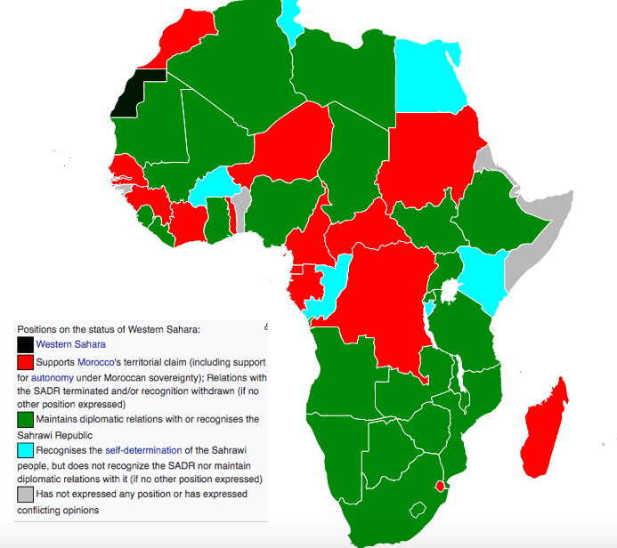
Figure 5- Map of AU Member official positions regarding the SADR

It is typically held that the countries Algeria, Zimbabwe, Kenya, Lesotho and Nigeria, who themselves have only relatively recently obtained independence from former colonial powers, are staunch supporters of West African independence.

Questions a resolution should consider:

How significant of a statement should these simultaneous yet opposing conferences be viewed as making? What should be the AU’s position in response to its member states’ seemingly opposing interests? Is it the AU’s responsibility to react? Is there a compromise to be obtained between the two declarations of intent? What are the next steps for either/both sides? Could this issue become more divisive in the near future? If so, how soon?

Conclusion

The tensions over the independence or annexation of Western Sahara are only rising within African states as Morocco is becoming increasingly influential in the AU and African trade relations. Very little success has been witnessed by either AU or UN peacemaking efforts, and no feasible solutions have been determined. The objective of the upcoming conference in October will be to determine the role, if any, of the AU in resolving the growing division between African member nations over this potentially monumental crisis. It is in the interest of the entire continent that a peaceful resolution be found to this longstanding issue, however the interests of some states involved are diametrically opposed to others, making such an outcome increasingly difficult.

Bibliography
Country profile: Morocco: https://www.cia.gov/library/publications/the-world-factbook/geos/mo.html

Country Profile: Western Sahara: https://www.cia.gov/library/publications/the-world-factbook/geos/wi.html

MINURSO home page. https://minurso.unmissions.org/about

Statehood: Montevideo Convention on the Rights and Duties of States. Art. 6, Dec. 26, 1933, 49 Stat. 3097, 165 L.N.T.S. 19.

Human Rights: UN Universal Declaration of Human Rights https://www.un.org/en/universal-declaration-human-rights/, Human Rights Watch https://www.hrw.org/world-report/2019/country-chapters/morocco/western-sahara

Security Issues: PSC Reports (Issued by the AU): https://issafrica.org/research/peace-and-security-council-report

Moroccan Economics/Trade: EU Trade Commission assessment http://ec.europa.eu/trade/policy/countries-and-regions/countries/morocco/

https://www.imf.org/external/np/country/notes/morocco.html

